Ideation Phase
Brainstorm & Idea Prioritization Template
Date | 06 July 2026
Team ID | [Insert Team ID as assigned by instructor]
Project Name | Food Ordering Behaviour and Customer Trends
Maximum Marks | 4 Marks

Brainstorm & Idea Prioritization Template:
Brainstorming provided a free and open environment that encouraged every member of the team to participate in the creative-thinking process leading to problem solving for the project, Food Ordering Behaviour and Customer Trends. Prioritising volume over value, out-of-the-box ideas were welcomed and built upon, and all participants collaborated to develop a rich set of analytical and design ideas.
This document records how the team used a structured brainstorming and prioritization process to move from an open problem space to a focused, feasible project plan, even while coordinating across individual schedules.
Reference: https://www.mural.co/templates/brainstorm-and-idea-prioritization

Step-1: Team Gathering, Collaboration and Select the Problem Statement
The team — David Goyar (Team Lead), Ravi Sharma, Kartik Gupta, and Harsh Naruka — came together to define the scope of the project. Relevant background on food-delivery datasets and prior Tableau dashboard examples was shared with all members ahead of the session, and each member confirmed their availability and role before the session began.
PROBLEM STATEMENT
How might we analyse food ordering behaviour and identify customer ordering trends using data analytics, so that food delivery platforms and restaurants can make informed, data-driven decisions about menu planning, pricing, and customer engagement?

Key Rules of Brainstorming Followed
✓ Stay on topic  Keep every idea tied to the problem statement on food ordering behaviour. | ✓ Encourage wild ideas  Unconventional analytical angles were welcomed before being filtered.
✓ Defer judgment  No idea was rejected during the listing stage; evaluation came later, in Step-3. | ✓ Listen to others  Each member reviewed and built upon ideas shared by teammates.
✓ Go for volume  The goal in Step-2 was quantity of ideas, not immediate quality. | ✓ Be visual  Ideas were grouped and plotted visually to aid shared understanding.

Step-2: Brainstorm, Idea Listing and Grouping

Individual Idea Listing (Sticky-Note Stage)
Each member independently listed ideas addressing the problem statement, without judgment or discussion, before the ideas were shared and clustered as a team.
David Goyar (Team Lead) | Ravi Sharma | Kartik Gupta | Harsh Naruka
Collect food ordering data covering order time, cuisine type, order value, city, and delivery duration. | Segment customers by order frequency: one-time, occasional, and frequent buyers. | Design an interactive Tableau dashboard showing order trends by city, cuisine, and time of day. | Build a responsive website to host and present all project outputs.
Study peak ordering hours across weekdays versus weekends to understand daily demand patterns. | Analyse the impact of discounts and promotional offers on order volume. | Build a Tableau Story to narrate key insights in a logical sequence. | Publish the Tableau dashboard on Tableau Public for open accessibility.
Analyse which cuisine types are most frequently ordered across different cities. | Track average order value trends across different customer segments. | Add dashboard filters for restaurant type, price range, and delivery time. | Host project code, datasets, and documentation on GitHub for transparency.
Examine the relationship between order value and delivery time. | Explore the correlation between restaurant ratings and order volume. | Use heat maps to visualise order density by location and hour. | Ensure the website and embedded dashboard are mobile-friendly.
Standardise and clean raw data to remove duplicate, missing, or inconsistent entries before analysis. | Investigate customer payment method preferences (cash, card, wallet, UPI). | Include KPI cards for total orders, average order value, and repeat-customer rate. | Add a summary/insights page on the website linking to the live dashboard and story.

Grouped Ideas (Thematic Clusters)
Once individual ideas were shared, similar and related ideas were clustered into themes, and each cluster was given a short label reflecting its focus area.
Cluster A — Data Collection & Preparation
Led by: David Goyar
- Sourcing food-ordering data (order time, cuisine, value, city, delivery duration).
- Cleaning and standardising raw data — removing duplicates and missing values.
- Identifying peak ordering hours and demand patterns by day/time.
Cluster B — Customer Behaviour & Segmentation
Led by: Ravi Sharma
- Segmenting customers by order frequency and value.
- Studying the effect of discounts/offers on order volume.
- Analysing payment method preferences and rating-order correlations.
Cluster C — Dashboard & Visualization Design
Led by: Kartik Gupta
- Building the interactive Tableau dashboard with filters and KPI cards.
- Creating the Tableau Story to communicate insights.
- Designing heat maps for order density by location and time.
Cluster D — Deployment & Accessibility
Led by: Harsh Naruka
- Publishing the dashboard on Tableau Public.
- Building and hosting the responsive project website.
- Maintaining the GitHub repository for code and documentation.

Step-3: Idea Prioritization
With the clustered ideas in hand, the team plotted each idea on an Importance-versus-Feasibility grid to agree on what mattered most and what was realistically achievable within the project timeline and available dataset.
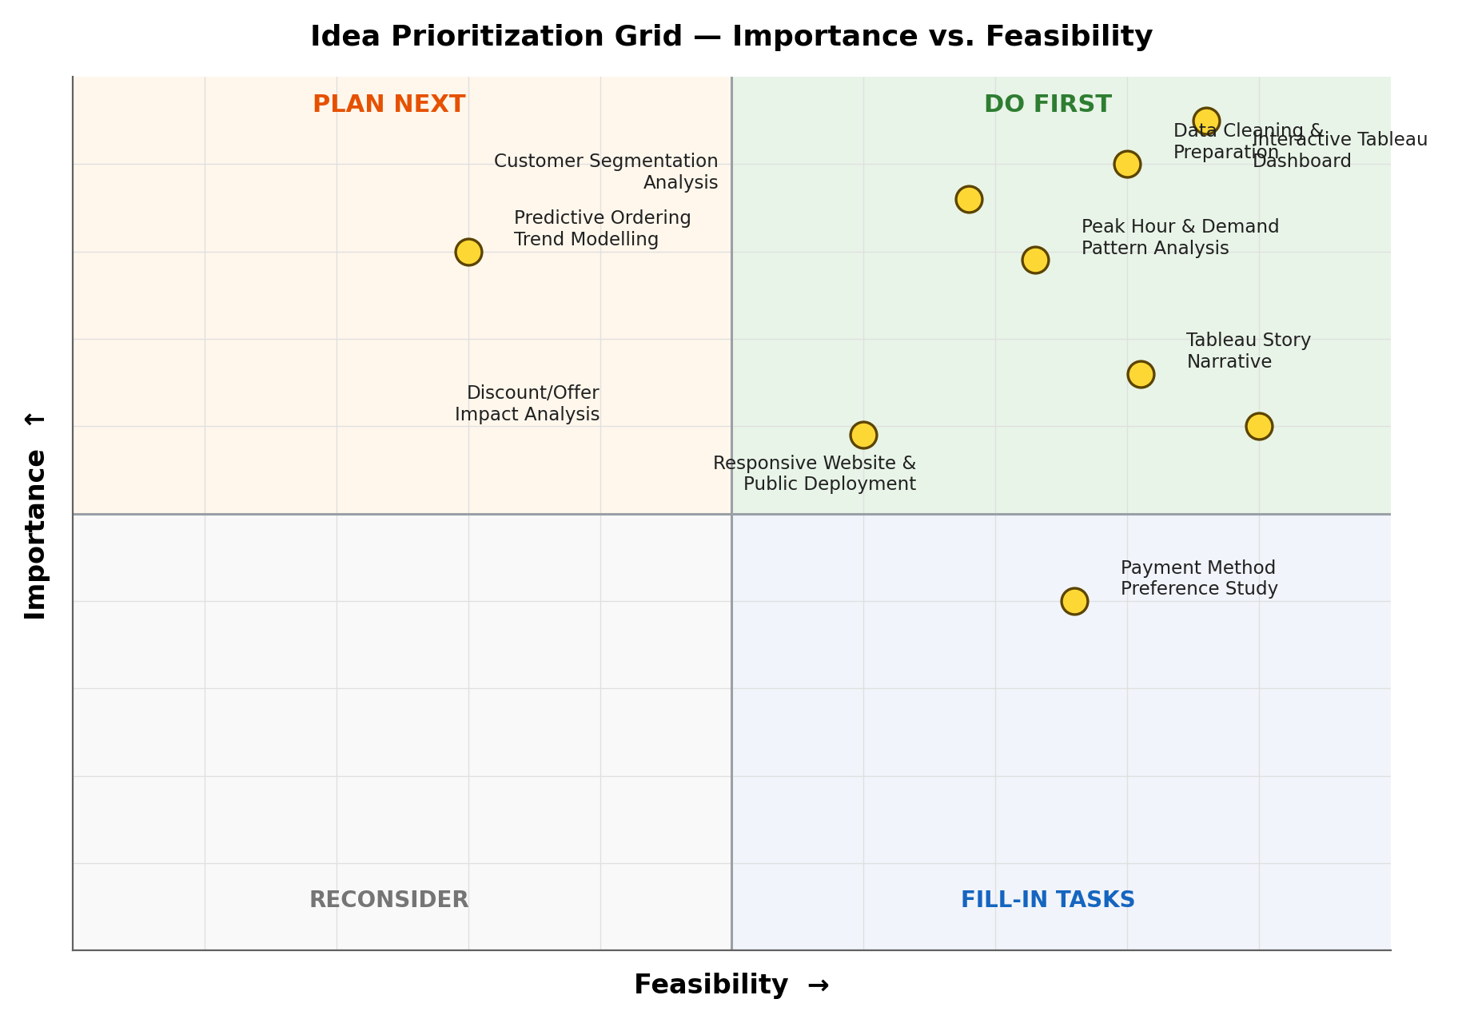

Prioritization Summary
Do First | Data Cleaning & Preparation; Interactive Tableau Dashboard; Customer Segmentation Analysis
Plan Next | Predictive Ordering Trend Modelling (kept as future scope due to limited feasibility with the current dataset)
Fill-in Tasks | Tableau Story Narrative; Responsive Website & Public Deployment; Payment Method Preference Study
Reconsider | Discount/Offer Impact Analysis (retained only as a secondary insight, not a core deliverable)

The ideas placed in the “Do First” quadrant — data cleaning and preparation, the interactive Tableau dashboard, and customer segmentation analysis — formed the core of the completed project, and were carried forward into the dataset collection, cleaning, Tableau Dashboard, Tableau Story, and Tableau Public deployment stages. The Tableau Story narrative and the responsive website/public deployment were treated as important supporting deliverables and were completed alongside the core analysis. Predictive ordering-trend modelling was consciously deferred as future scope, since it required a longer time-series dataset than was feasible for the current project.

